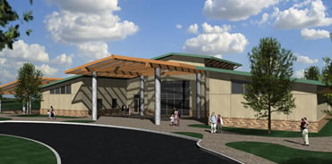
Family Fieldtrip Day, Sat. March 25, 2017
See local ice-age fossils in the museum, watch a cool film,
and do some fossil digging!
Meet at the museum entrance at 10:00am (our tour begins at 10:15), bring a sack lunch, if you like, or head to lunch afterwards. Drive your car (about 74 miles), or arrange a carpool. All are Fair Oaks 6th graders and their families are welcome. The tour and dig should be over by 12:00pm.
Cost: Last year’s cost was adults $6, Students $7 (includes the dig). This will be verified for this year on March 21.

Please try to rsvp by March 23, so we can give the museum an idea of how many to expect. Contact Mr. Eisman Rm. 18 (veisman@ojusd.org or text: (734) 648-2334)

The San Joaquin Valley Paleontology Foundation was formed in 1996 after the discovery of the Fairmead Fossils in Madera County, California. The Fairmead Fossils are found at the Madera County landfill, which is located in the small town of Fairmead just south of Chowchilla. These fossils were first discovered when a scraper was moving dirt and the alert equipment operator noticed some unusual coloration of the soil. Investigation revealed a complete fossil of a Columbian Mammoth tusk, which was dated at approximately 500,000 years old. In a short time, scientists realized that the landfill was located on one of the most significant fossil beds discovered from the Pleistocene period (Ice Age).

